R=1;

L=0.5;

Kt=0.01;

J=0.01;

b=0.1;

num = Kt;

den = [(J*L) (J*R)+(L*b) (R*b)+(Kt^2)];

Ts = 0.12;

[numz,denz] = c2dm(num,den,Ts,'zoh')

numz = [numz(2) numz(3)];

[numz_cl,denz_cl] = cloop(numz,denz);

[x1] = dstep(numz_cl,denz_cl,101);

t=0:0.12:12;

stairs(t,x1)

xlabel('Time (seconds)')

ylabel('Velocity (rad/s)')

title('Stairstep Response:Original')

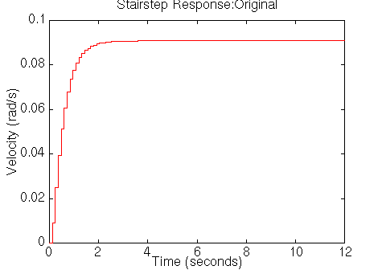

**PID Controller**

http://instruct.uwo.ca/engin-sc/391b/CTM/examples/motor/Con_PID.gif

http://instruct.uwo.ca/engin-sc/391b/CTM/examples/motor/mapping.gif

http://instruct.uwo.ca/engin-sc/391b/CTM/examples/motor/bilinear.gif

% Discrete PID controller with bilinear approximation

Kp = 100;

Ki = 200;

Kd = 10;

[dencz,numcz]=c2dm([1 0],[Kd Kp Ki],Ts,'tustin');

numaz = conv(numz,numcz);

denaz = conv(denz,dencz);

[numaz_cl,denaz_cl] = cloop(numaz,denaz);

[x2] = dstep(numaz_cl,denaz_cl,101);

t=0:0.12:12;

stairs(t,x2)

xlabel('Time (seconds)')

ylabel('Velocity (rad/s)')

title('Stairstep Response:with PID controller')

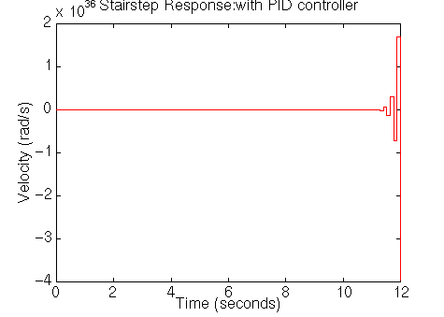

rlocus(numaz,denaz)

title('Root Locus of Compensated System')

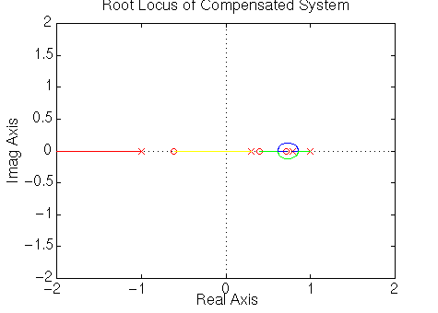

dencz = conv([1 -1],[1.6 1])

numaz = conv(numz,numcz);

denaz = conv(denz,dencz);

rlocus(numaz,denaz)

title('Root Locus of Compensated System');

[K,poles] = rlocfind(numaz,denaz)

[numaz_cl,denaz_cl] = cloop(K*numaz,denaz);

[x3] = dstep(numaz_cl,denaz_cl,101);

t=0:0.12:12;

stairs(t,x3)

xlabel('Time (seconds)')

ylabel('Velocity (rad/s)')

title('Stairstep Response:with PID controller')

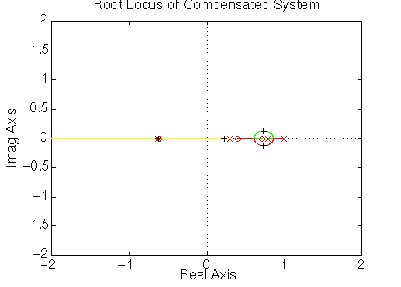

Then Matlab will return the appropriate gain and the corresponding compensated poles, and it will plot the closed-loop compensated response as follows.

